Muhammad Iqbal Aulawi

Day1 -System Design

**Q1**  
Aplikasi Expense Tracker

ERD

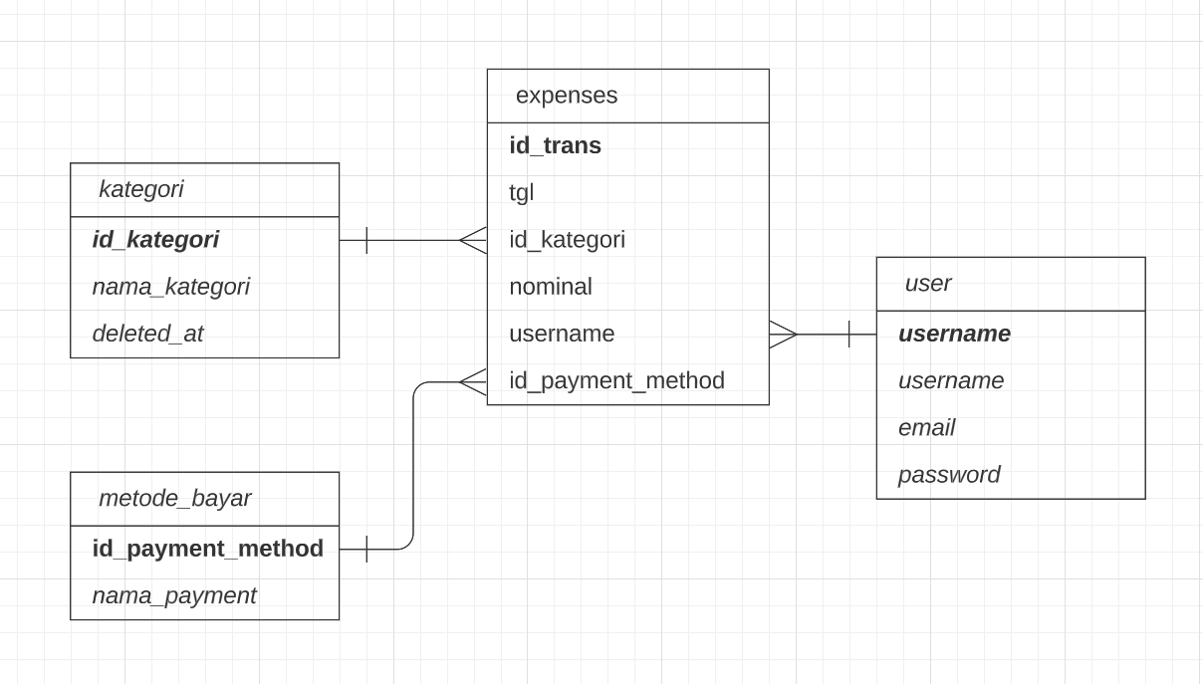

USECASE

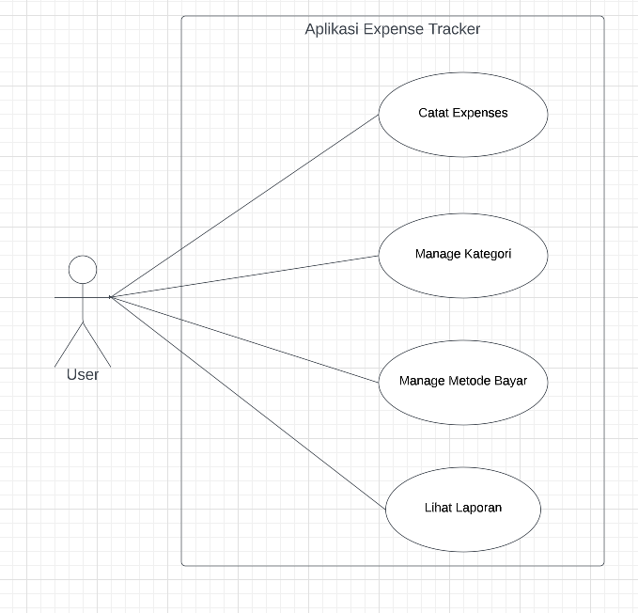

**Q2**

MySQL :

**SELECT * FROM USERS**

Redis :

**KEYS "users:*"**

NEO4j :

**MATCH(u:USERS)**

**RETURN u**

Cassandra :

**SELECT * FROM USERS**